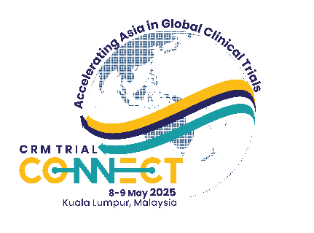

*Organizers:*

**Oncology Workshop**

6–7 May 2025, Kuala Lumpur



**PROTOCOL CONCEPT SHEET**

**Application is via submission of the completed Protocol Concept Sheet, to brcc@clinicalresearch.my**

**Application Deadline: 14 April 2025**

APPLICANT Name:

DESIGNATION:

oRGANISATION:

E-MAIL AdDRESS:

__________________________________________________________________________________

1. **What is the title of the study?**
2. **What is the main objective of the trial?**
3. **What is the proposed trial design?**
4. **What is the rationale for performing this trial?**
5. **What are the characteristics of the population under study?**
6. **What are the planned trial interventions?**
7. **What are the endpoints (outcome measures)?**

(Can be further discussed with workshop facilitators during the workshop)

1. **Is the study randomized?**

(Can be further discussed with workshop facilitators during the workshop)

**Note: Please also consider the feasibility of the study**

Example:

* Do you have access to adequate supplies of the drugs under study?
* Do you have access to the required number of patients to perform the study?